Website on a shop that sells games and merchandise

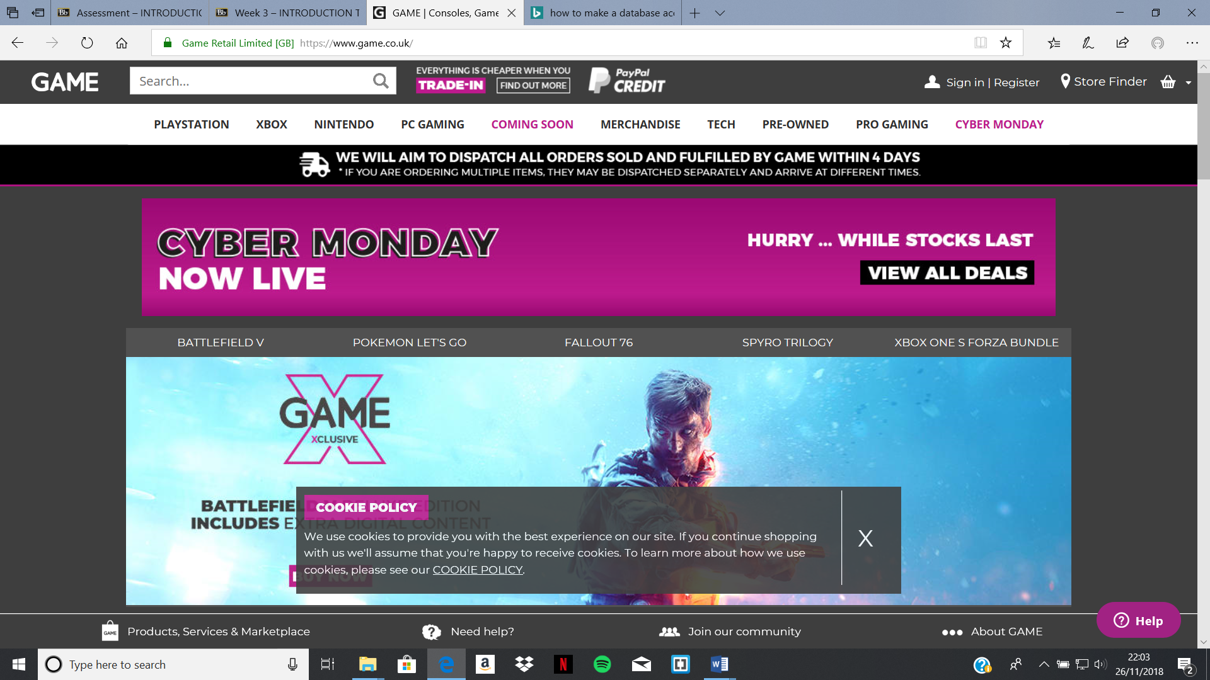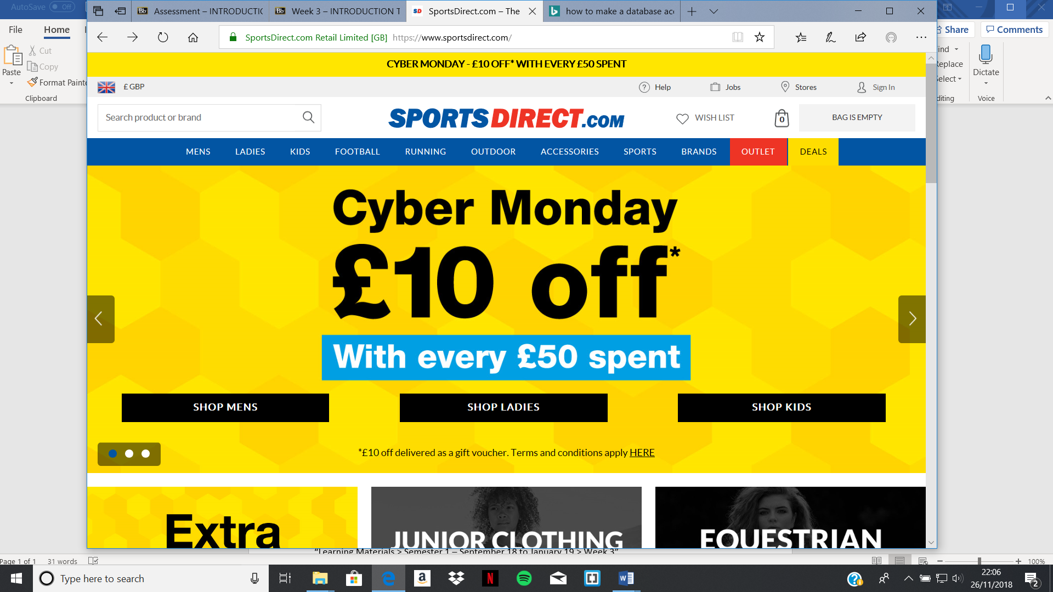

Add a site path (with links) to help navigation

“Learning Materials > Semester 1 – September 18 to January 19 > Week 3”

